LAB 8

NAYAKANTI SAI MIHIRNATH - 210905368

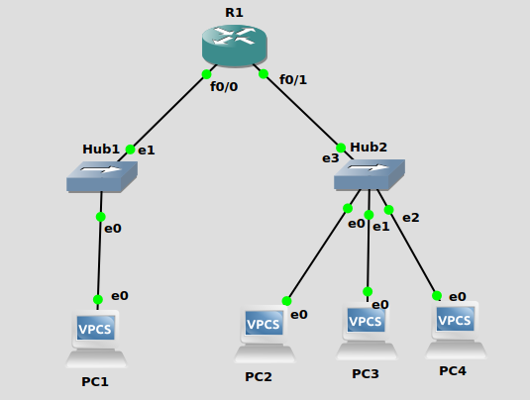

Configuring PC’s : -

PC1 : -
ip 10.0.1.10/24 10.0.1.1
PC2 : -
ip 10.0.2.10/24 10.0.2.138
PC3 : -
ip 10.0.2.137/29 10.0.2.138
PC4 : -
ip 10.0.2.139/24 10.0.2.138

Configuring Router : -

conf t
int f0/0
ip address 10.0.1.1 255.255.255.0
no shut
exit
int f0/1
ip address 10.0.2.138 255.255.255.0
no shut
exit
do wr

